**Supplemental Materials for ‘Establishing causality in the mediator-outcome relationship: Experimental mediation and the use of instrumental variable regression’**

Table of Contents

S1 Additional Results under Normality Assumptions 3

S1.1 Estimation Bias of the Indirect Effect 3

S1.2 Coverage Rate of the Indirect Effect 5

S1.3 Type I Error Rate of the Indirect Effect When $a=0$ and $b=0.14$ 7

S2 Results under The Asymptotically Distribution Free (ADF) Assumptions 9

S2.1 Estimation Bias of the Indirect Effect 9

S2.2 Coverage Rate of the Indirect Effect 10

S2.3 Type I Error Rate of the Indirect Effect 11

S2.4 Statistical Power of the Indirect Effect 12

# S1 Additional Results under Normality Assumptions

## S1.1 Estimation Bias of the Indirect Effect

**Figure S1.**

*Estimation Bias of the Indirect Effect When $a=0$ Under Normality Assumptions*

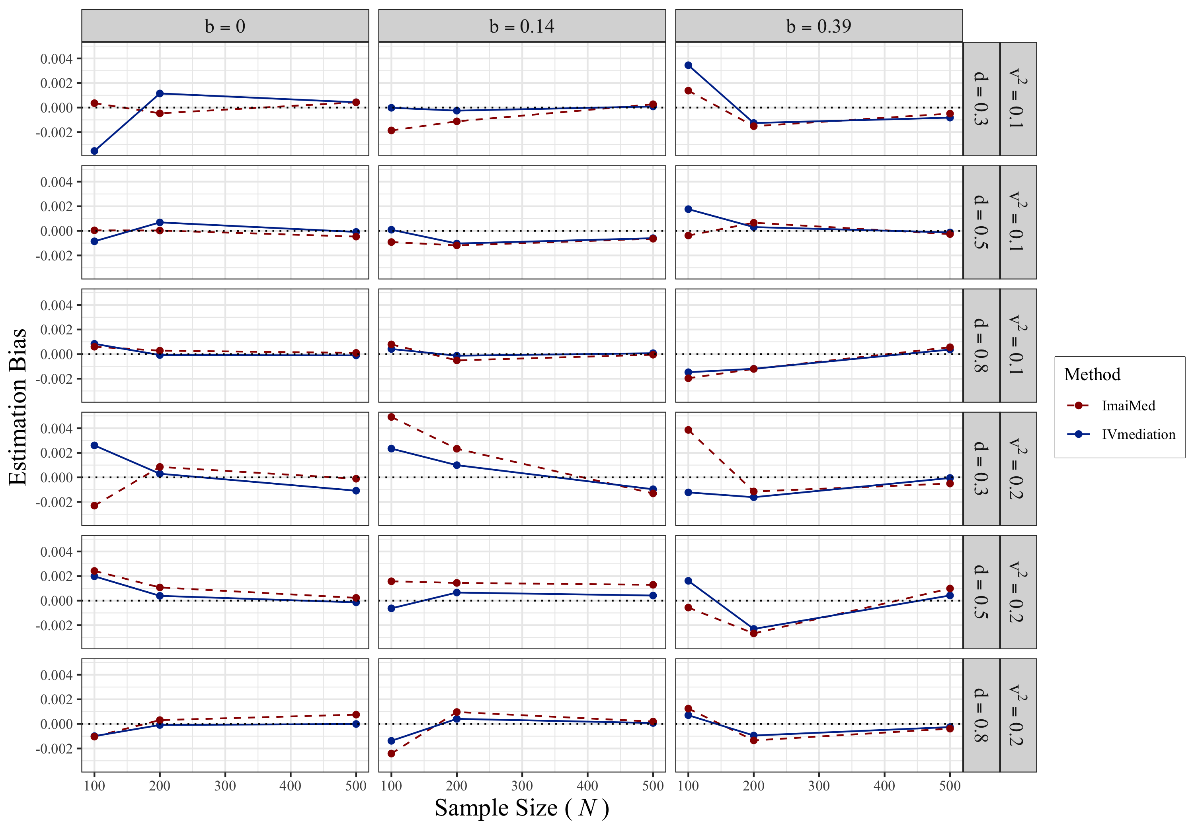

*Note.* The horizontal black dotted line marks 0 Estimation Bias.

**Figure S2.**

*Estimation Bias of the Indirect Effect When $d$ Equaled $0.3$ and $0.8$ with $a=0.39$ Under Normality Assumptions*

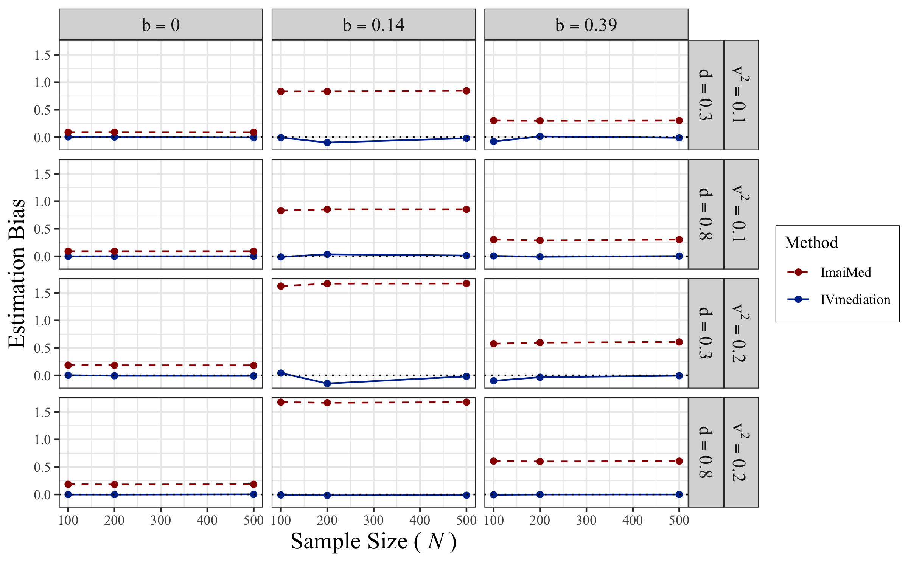

*Note.* The horizontal black dotted line marks 0 Estimation Bias.

## S1.2 Coverage Rate of the Indirect Effect

**Figure S3.**

*Coverage Rate of the Indirect Effect When $a=0$ Under Normality Assumptions*

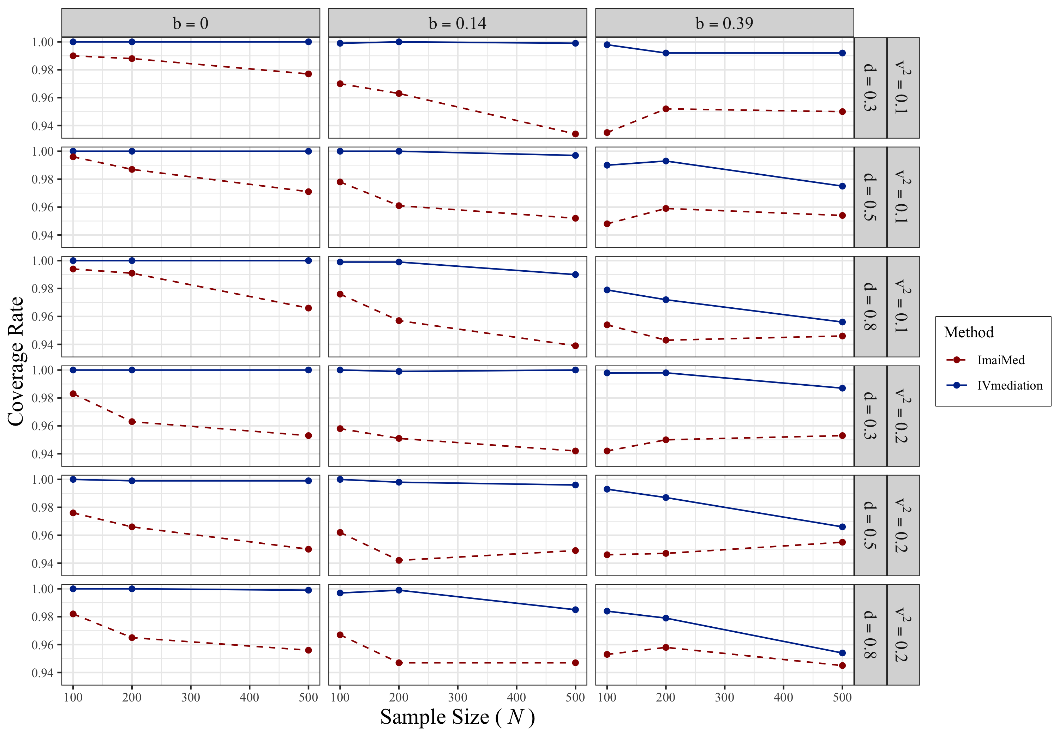

**Figure S4.**

*Coverage Rate of the Indirect Effect When $d$ Equaled $0.3$ and $0.8$ with $a=0.39$ Under Normality Assumptions*

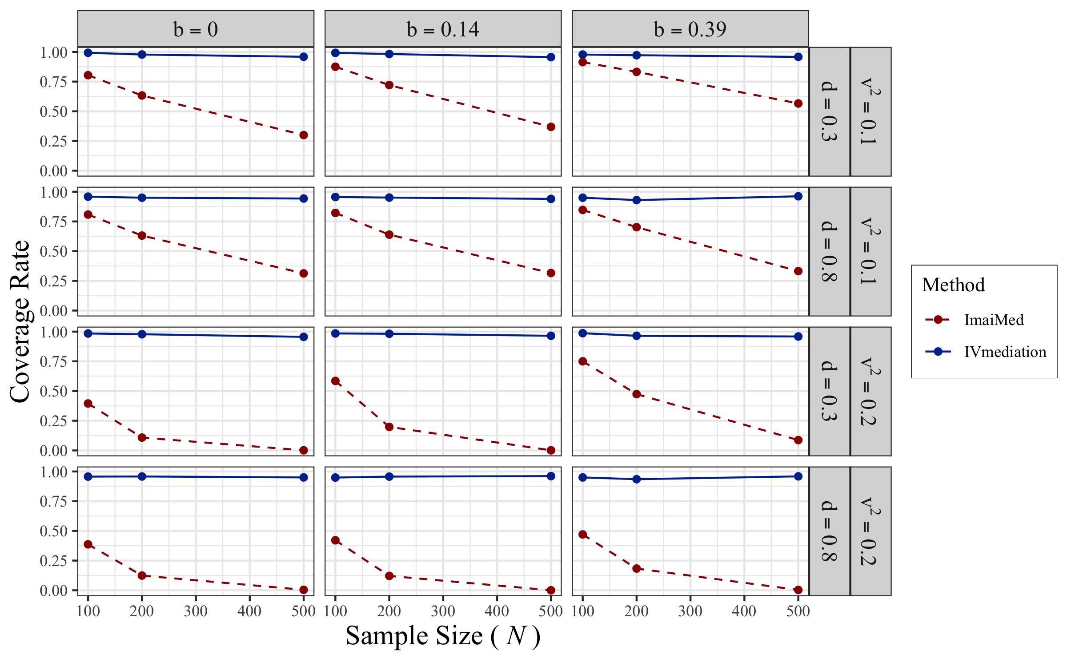

## S1.3 Type I Error Rate of the Indirect Effect When $a=0$ and $b=0.14$

**Figure S5.**

*Type I Error Rates of the Indirect Effect When $a=0$ Under Normality Assumptions*

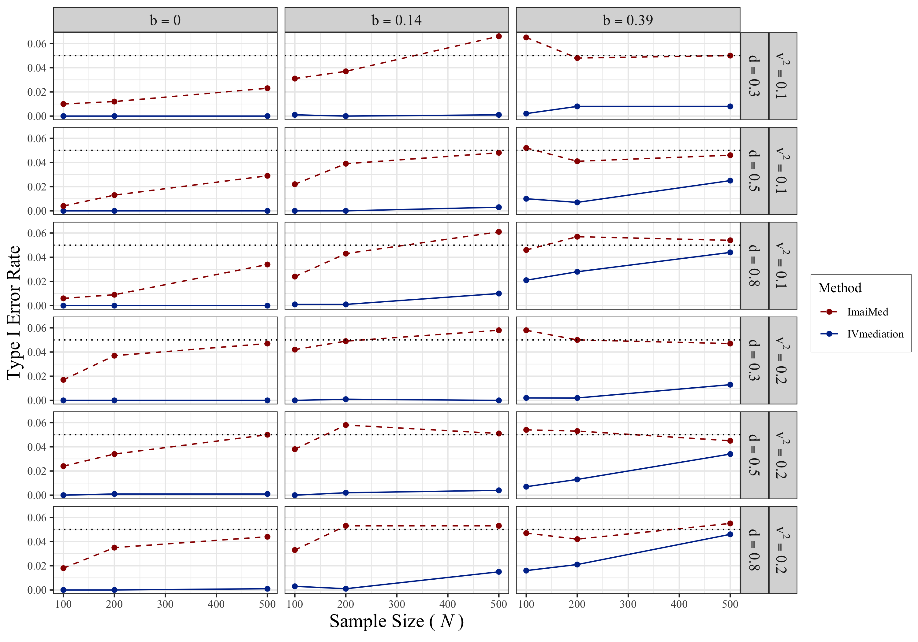

**Figure S6.**

*Type I Error Rates of the Indirect Effect When $d$ Equaled $0.3$ and $0.8$ with $a=0.39$ Under Normality Assumptions*

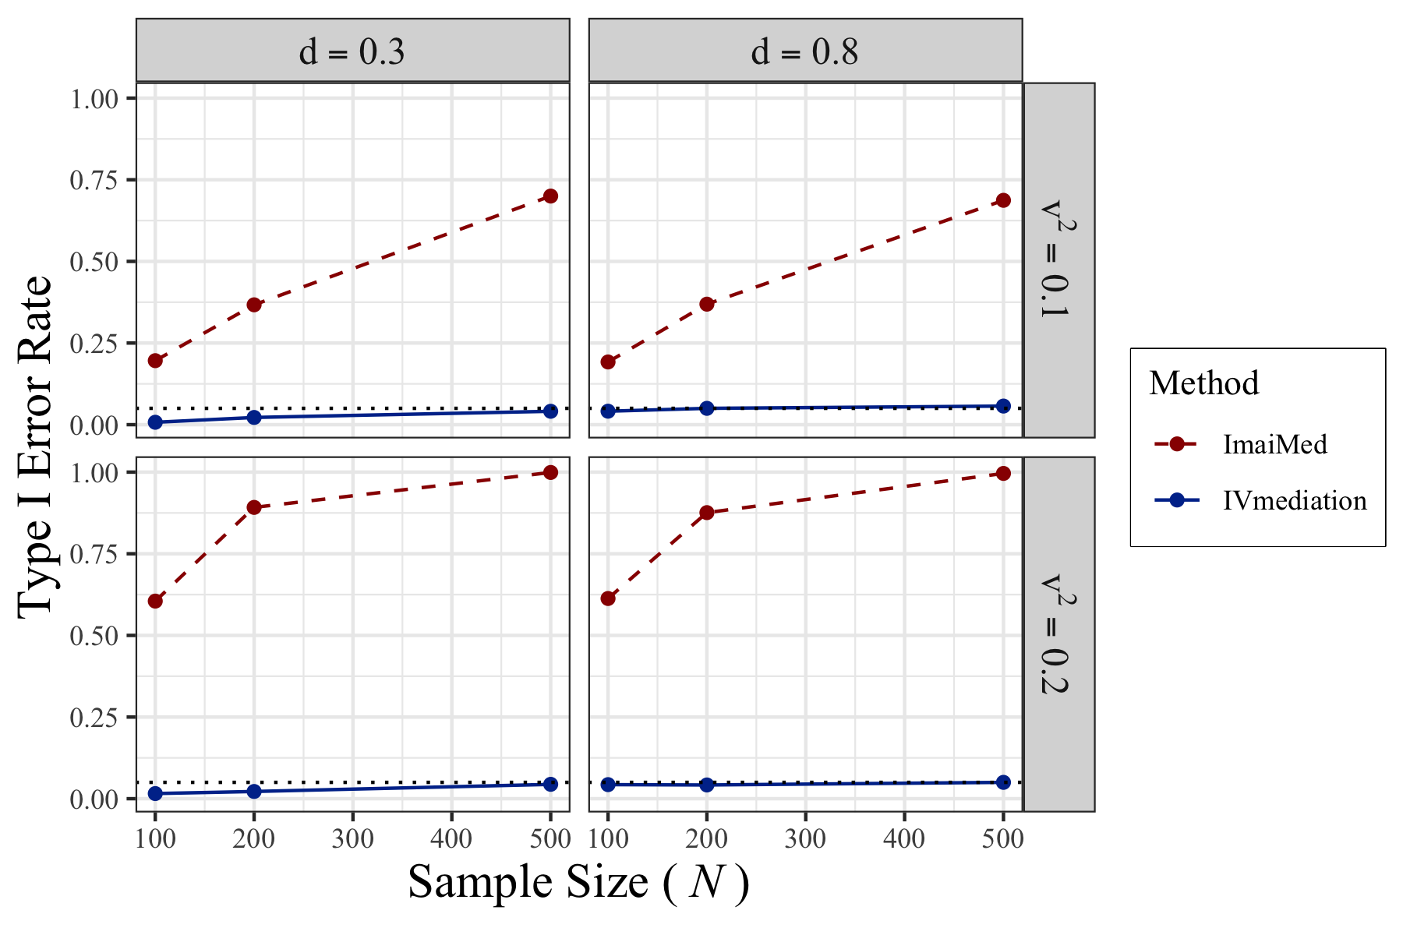

S1.4 Statistical Power of the Indirect Effect When $v=\sqrt{0.1}$

**Figure S7.**

*Statistical Power of the Indirect Effect When $v=\sqrt{0.1}$* *Under Normality Assumptions*

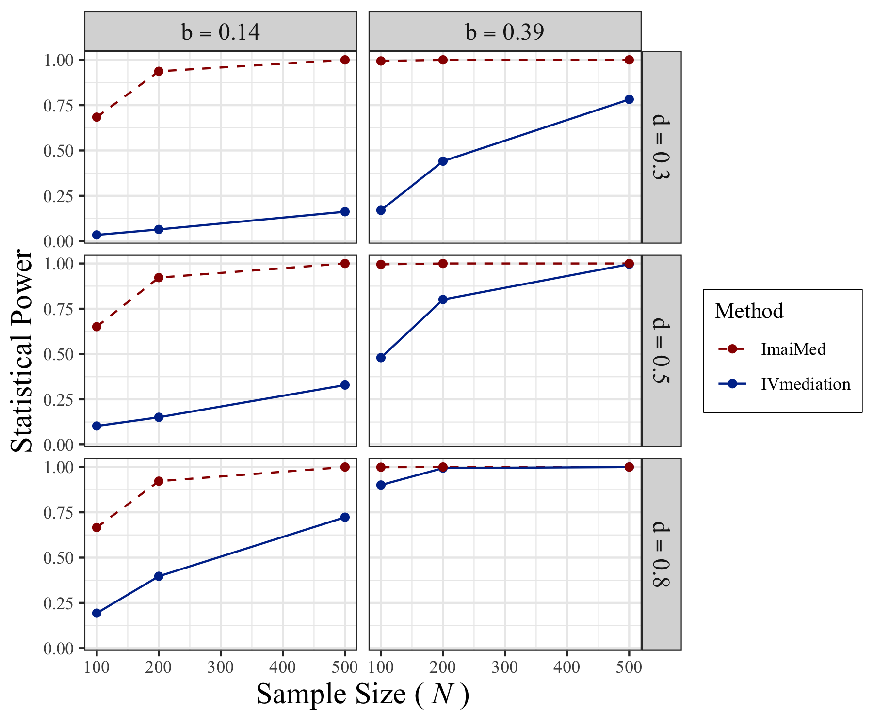

# S2 Results under The Asymptotically Distribution Free (ADF) Assumptions

## S2.1 Estimation Bias of the Indirect Effect

**Figure S8.**

*Estimatino Bias of the Indirect Effect under ADF Assumptions*

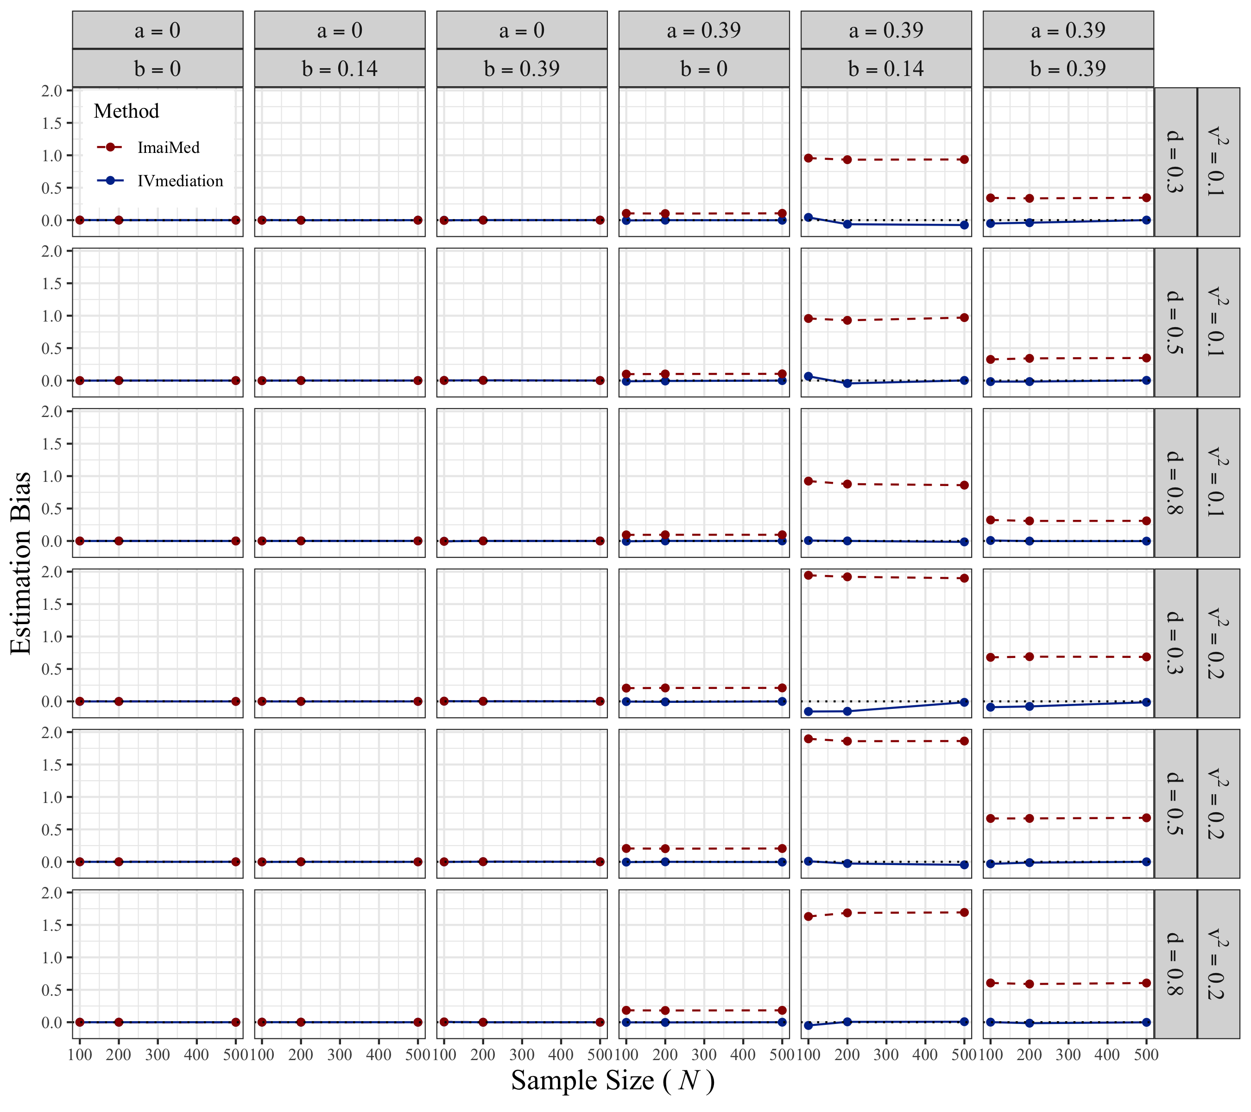

## S2.2 Coverage Rate of the Indirect Effect

**Figure S9.**

*Coverage Rate of the Indirect Effect under ADF Assumptions*

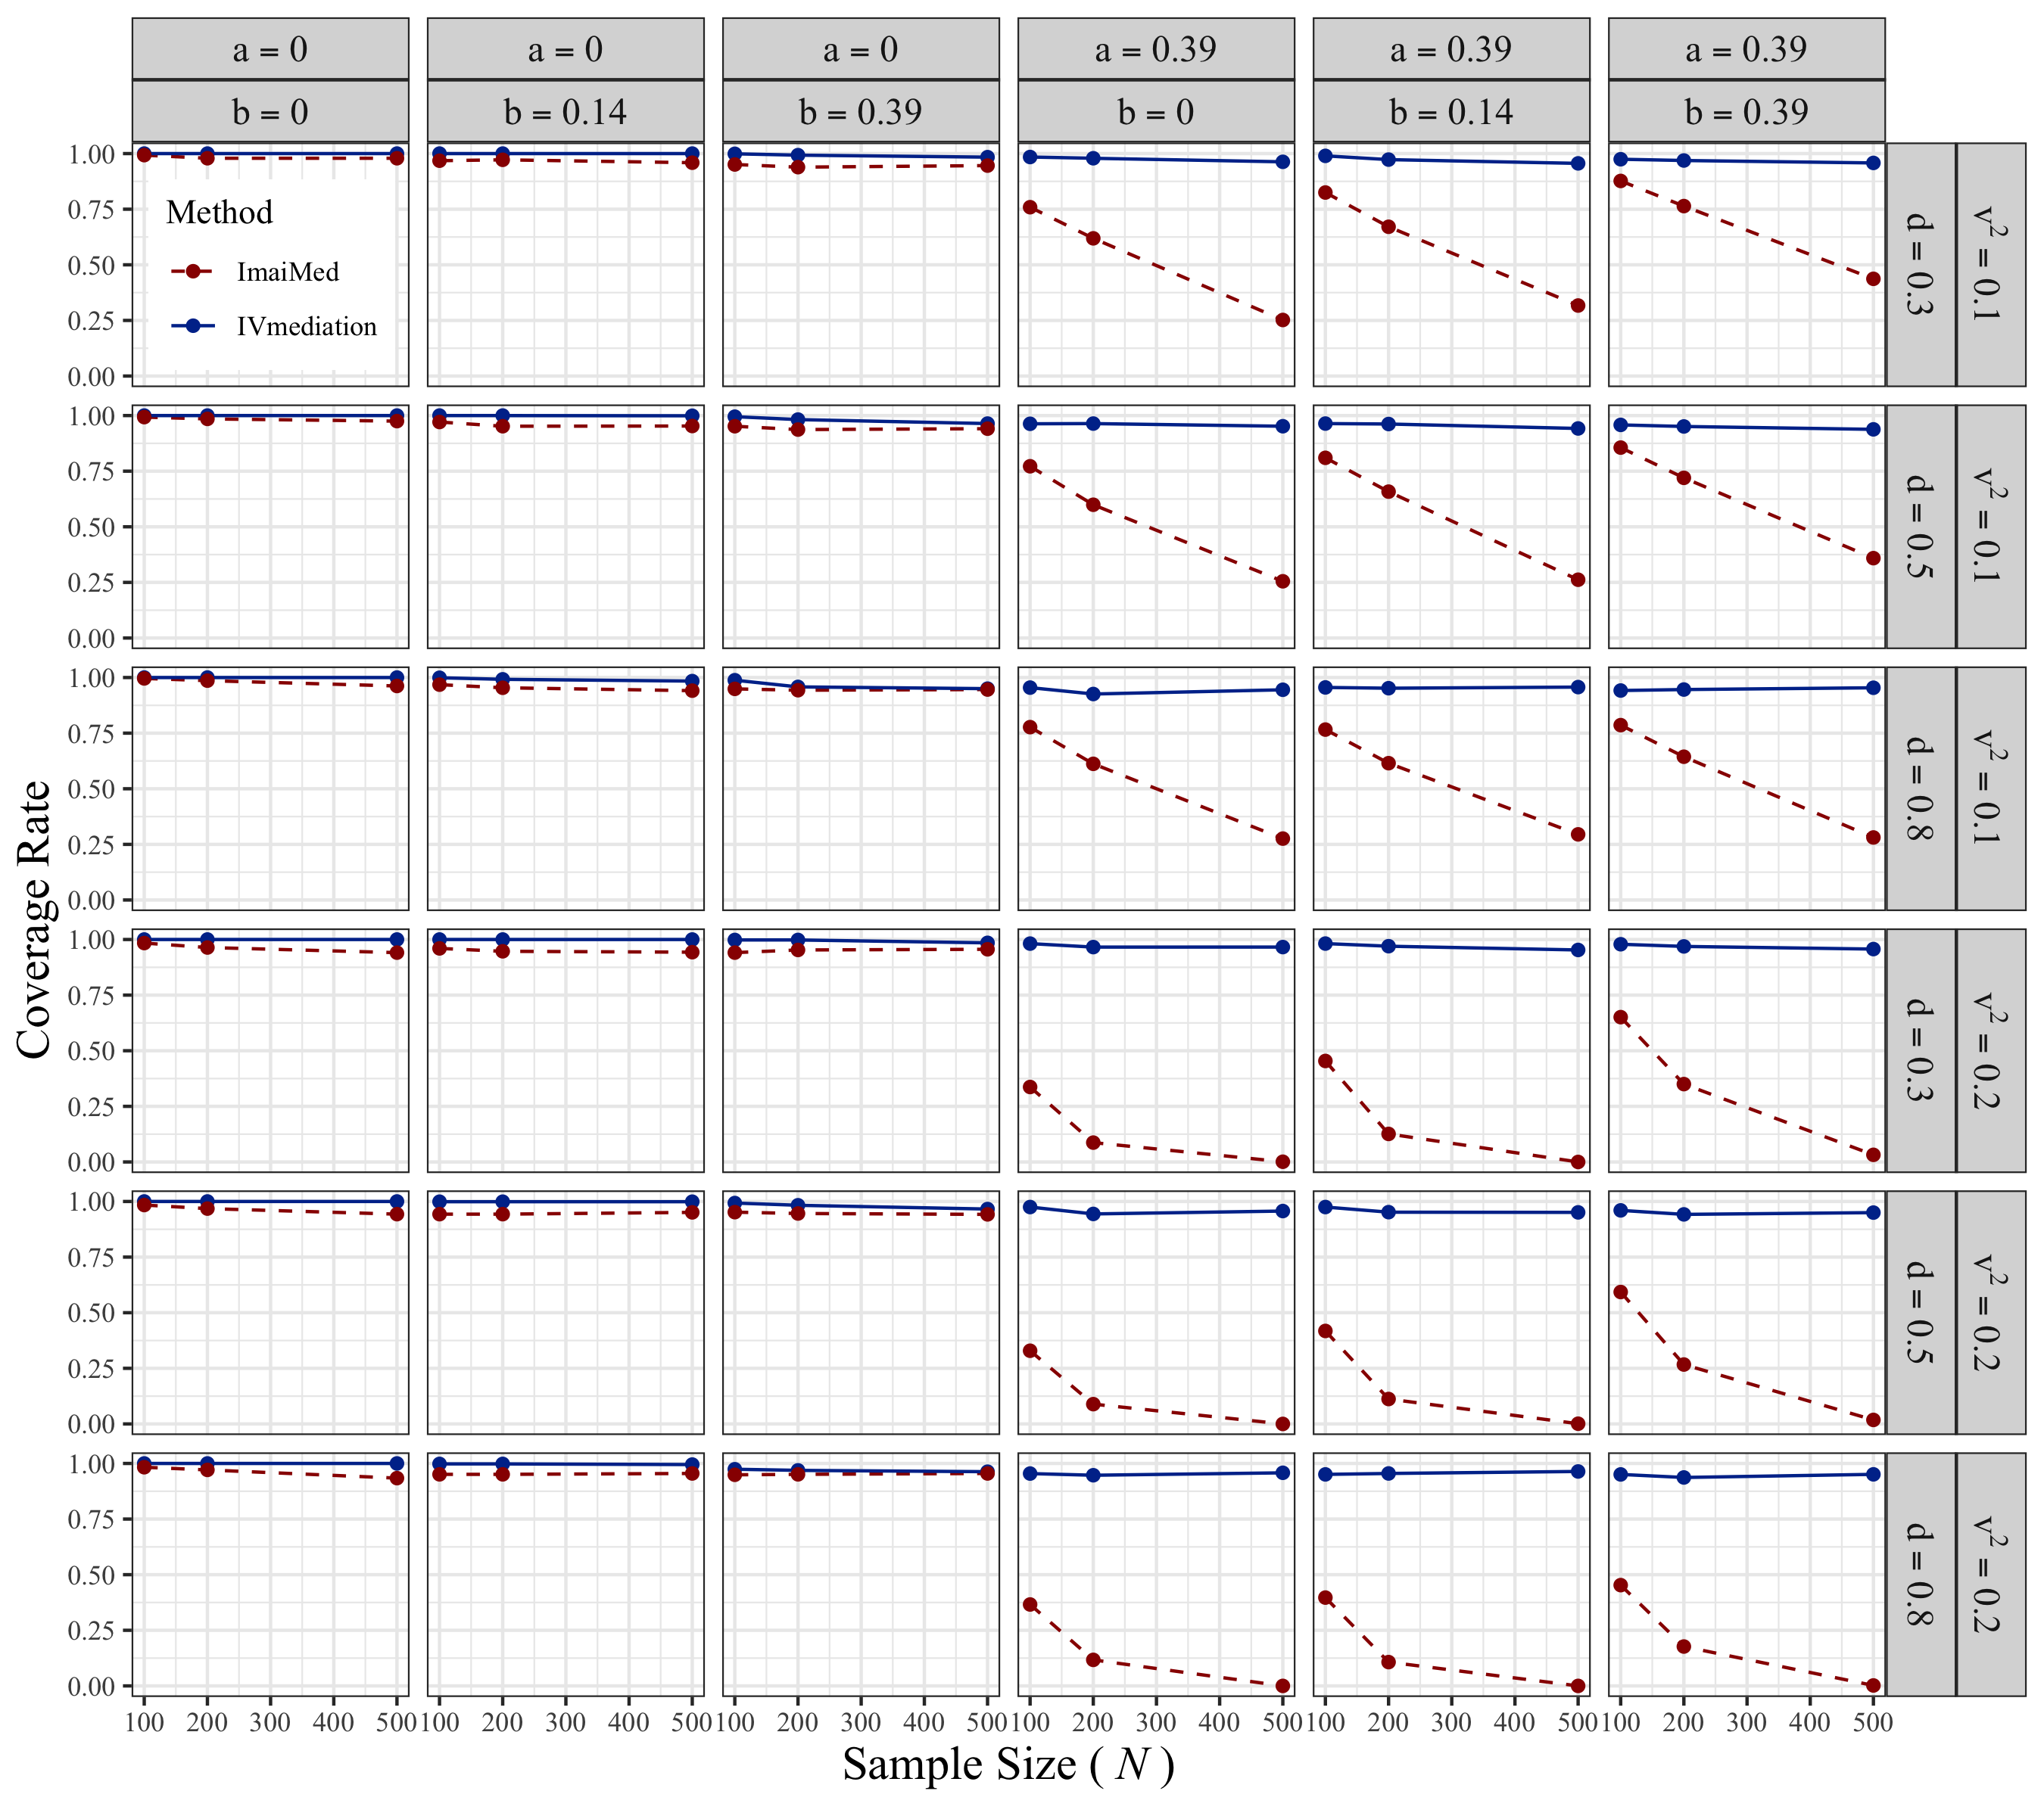

## S2.3 Type I Error Rate of the Indirect Effect

**Figure S10.**

*Type I Error Rate of the Indirect Effect under ADF Assumptions*

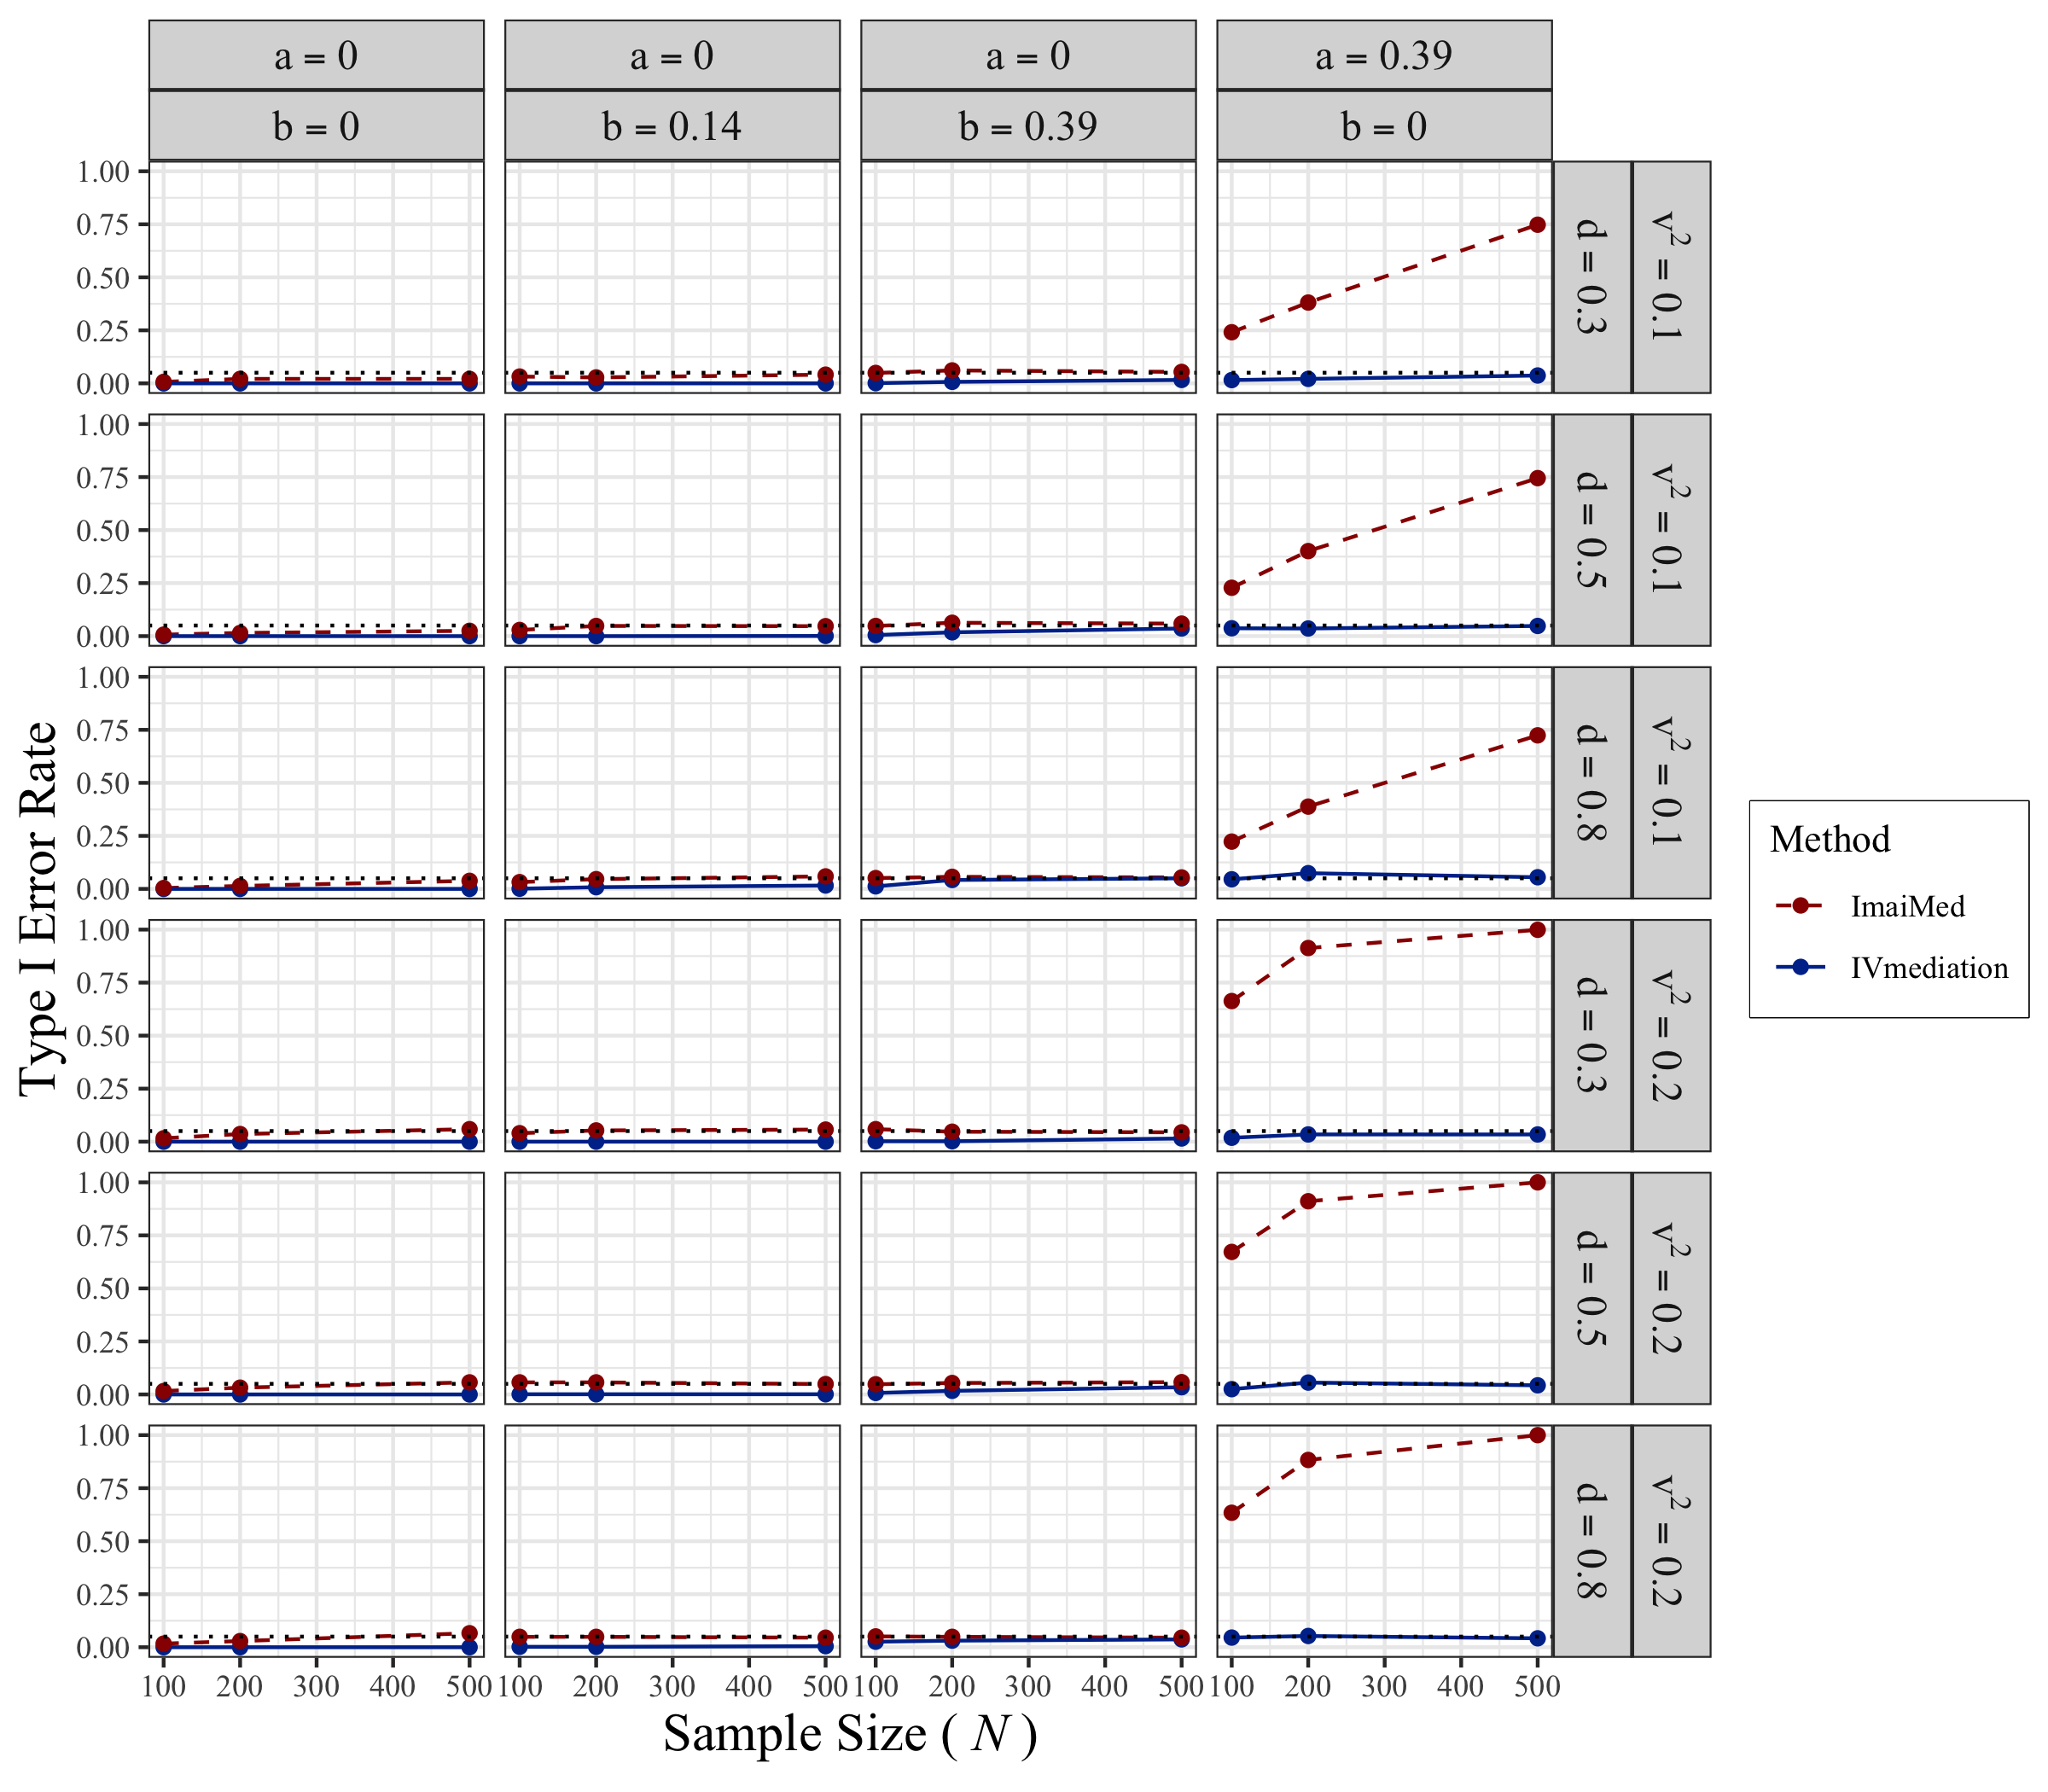

## S2.4 Statistical Power of the Indirect Effect

**Figure S11.**

*Statistical Power of the Indirect Effect under ADF Assumptions*

